13 Smart Ways to Stand Out at Your Next Trade Show
Inc.com/young-entrepreneur-council/
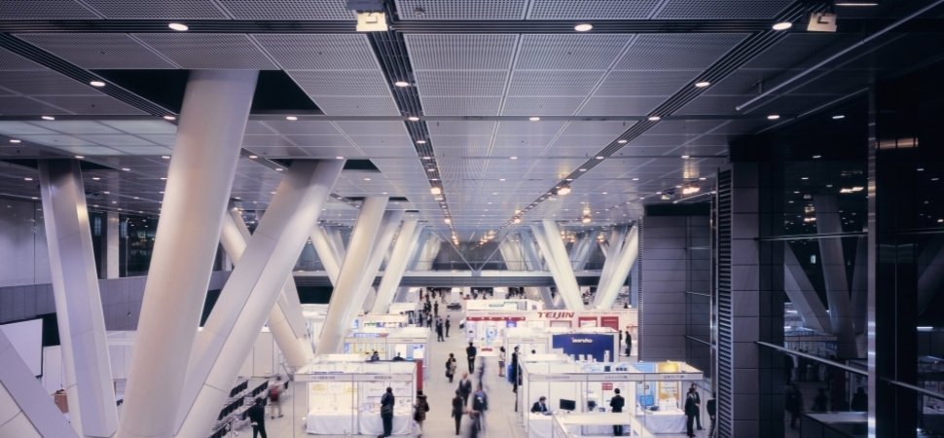
CREDIT: Getty Images
Trade shows are an excellent way for your business to gain exposure and meet prospective clients. But with the convention center crawling with flashy, gimmicky competitors, it's easy for the new kid on the block to overlooked.
To ensure you're gaining maximum ROI from your time and money spent on booth space and making an appearance, it's best to think strategically about how you're going ensure your business is the one being talked about.
Thirteen entrepreneurs from Young Entrepreneur Council (YEC) share their surefire ways to make your exhibit one that attendees will remember.

1. Start long before you get there.
Last year, I watched Joel Klette do this masterfully. In the weeks leading up to the event, he had conference attendees vote on swag they wanted him to handout -- logos, pencils, T-shirts, etc. He exercised the event's hashtag and put together engaging, image-rich tweets that stuck way out. He didn't have a booth but was probably more popular than those who did. Bravo!--Adam Steele, The Magistrate

2. Give away something unusual.
Free corporate pens and mugs are totally unoriginal and can actually aggravate passersby, rather than entice them! You can stand out from the bland big dogs by giving away something quirkier and still putting your company's brand on it. Corporate headphones, balloons, laptop skins, socks, sunglasses, even Rubik's cubes; the options are endless, and the chances of standing out are huge!--Marvin Amberg, Caseable

3. Create buzz among attendees with humor.
Remember that buzz means conversation. You want to provide customers who go past your booth with opportunities for conversation. I think "keep it positive" can fall flat. We hear positive marketing messages so often, they become dull. Step up and provide people with something humorous they can pass along, and you'll get people talking about you.--Brandon Stapper, 858 Graphics

4. See what you're up against.
Do your research. Check out the "big dogs" and learn from what they're bringing to the trade show -- not just staff-wise but visually. Do they have a collection box to gain customers? Contests? Candy? These are some of the things you can look at so you can make sure you're prepared.--Jayna Cooke, EVENTup

5. Boast your "As Seen On" features.
If your brand can be seen on a myriad of websites, use it as a focus point in your trade show set-up. Create a booth design that accentuates these features, with a huge shoutout to "As Seen On" right in front of trade show attendees. This will definitely get curiosity and buzz going for your brand.--Miles Jennings, Recruiter.com

6. Invest in a great display.
I've seen even some of the big companies bring some really sad-looking tables to a trade show. If you want to look bigger and more invested (and more investable!) then consider this part of your marketing budget for the year. If you have something printed that looks really great, you can also save it for future shows.--Matt Doyle, Excel Builders

7. Hand out bigger reusable bags than the competition.
Everyone at a trade show gives stuff away, and each presenter usually has their own bag to put their swag in. The biggest bag usually wins, becoming the receptacle for all the other bags' contents. Pony up and make it reusable, so the bag lives on beyond the trade show and won't end up in the trash like all the others.--Michael Portman, Birds Barbershop

8. Be the life of the party.
Let's face it, most "big dogs" and industry events are boring. If you want to be the new kids on the block, then make your presence felt and have fun. Your competition is probably a lot less excited about the opportunity to be at the event, so make some noise. Throw an after-party, become friends with everyone, have an interactive booth, and enjoy it. Nothing beats being young at heart!--Matt Wilson, Under30Experiences

9. Create the longest line.
Something as simple as putting together a well-designed shirt and giving it away for free can create immediate and long-lasting buzz; make sure it's something people want to wear, and don't be afraid to encourage them to put it on immediately. Tell them you'll buy them a beer if you see them wearing it at the networking parties after the convention day ends.--Blair Thomas, EMerchantBroker

10. Create a video about your brand.
At most industry trade shows, company executives do a lot of blabbing about their company. Why not throw in a visual asset? A cool video about your company or one of your new products will impress your peers and your will be sure to make a splash at your industry trade show.--Stanley Meytin, True Film Production

11. Use creative stunts to get people's attention.
The big guys often use fancy pop-up displays and don't mess with customizing anything. We beat those exhibitors every time on a very small budget. Two years ago, we partnered with the local zoo to bring two penguins to our trade show booth. People crowded around our booth from the moment the show began. We handed out penguin-themed flyers and penguin stress balls. People STILL remember it!--Jesse Lear, V.I.P. Waste Services, LLC

12. Use design to your advantage.
We're all attracted to great design, whether we know it or not. At trade shows and conventions, it's easy to have everything blend together visually. Make sure you have a booth that stands apart from the competition -- using design as a differentiator. Hire a group whose work you love and doesn't specialize in exhibit design to get the best results.--Lee Salisbury, UnitOneNine

13. Send emails in advance to attract more visitors.
Whenever we do trade shows, we go through a list of attendees expected to visit, which organizers can provide to you. We send out emails to people we want to meet, and many of them will respond and stop by our booth. This helps us meet key people without wasting time during the event. In fact, we saw so many visitors at our booth using this strategy, our competitors were surprised with our numbers.--Piyush Jain, SIMpalm
The opinions expressed here by Inc.com columnists are their own, not those of Inc.com.

